

ATAR Physics

Year 12 2019

**Task 1:**

**Investigation of motion on an inclined plane**

Student Name: _______________________________

Investigation date: ___________

I acknowledge that all the information contained in this task is my own work and not taken from other sources. If other sources have been used they have been acknowledged in my references.

____________________________________

**TOTAL MARKS**

**/60**

(Student Signature)

Teacher Comments:

This assessment will be completed in two phases. The first part will be some in class pre-Investigation questions completed individually, and the second part will be completed by conducting the experiment in pairs and individually completing the required analysis of results and questions that follow.

## Background – Science as a Human Endeavour

Galileo Galilei (1564-1642) is considered to be one of the fathers of modern science due to his extensive research in Astronomy and Physics. During the early part of the seventeenth century, Galileo experimentally examined the concept of acceleration. One of his goals was to learn more about freely falling objects.

Unfortunately, his timing devices were not precise enough to allow him to study free fall directly. Galileo was limited to using his pulse of very simple water timers to get an indication of time. Therefore, he decided to limit the acceleration by using fluids, inclined planes, and pendulums. In this lab exercise, you will see how the acceleration of a rolling cart depends on the ramp angle. Then, you will use your data to **extrapolate** to the acceleration on a “vertical ramp;” 🡪 that is, the acceleration of a cart in free fall.

If the angle of an incline with the horizontal is small, a cart rolling down the incline moves slowly and can be easily timed. Using time and position data, it is possible to calculate the acceleration of the cart. When the angle of the incline is increased, the acceleration also increases. The acceleration is directly proportional to the sin of the incline angle, (θ).

A graph of acceleration versus sin θ can be extrapolated to a point where the value of sin θ is 1. When sin θ is 1, the angle of the incline is 90°. This is equivalent to free fall. The acceleration during free fall can then be determined from the graph.

Galileo was able to measure acceleration only for small angles. You will collect similar data. Can this data be used in extrapolation to determine a useful value of g, the acceleration of free fall?

You will make quantitative measurements of the motion of a cart rolling down inclines of various small angles. From these measurements, you should be able to decide for yourself whether an extrapolation to large angles is valid.

**MATERIALS**

Dynamics Cart and Ramp

Metre rule

Stopwatch

Small piece of woods and/or other props

Recording device

## PROCEDURE

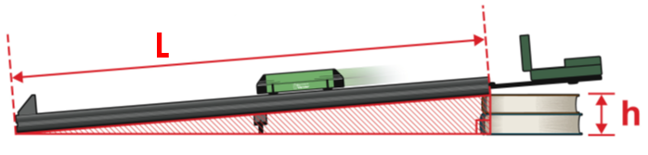

1. Setup the ramp as shown, with the metre rule positioned along the side. Small pieces of wood or other props such as textbooks may be used to create the height “h”.
2. Measure the height “h” to the nearest mm. (Measure to the bottom corner of the track)
3. Conduct a practice run. Hold the cart on the incline near the base of the ramp, and using a fairly small force, push the trolley up the ramp and let it roll back again try to catch it before it hits the bottom (placing your foot at the base of the ramp is a good way to stop it). The practice run is to get a feel for the size of forces required.
4. Conduct your first run. Your partner should be recording the run such that the displacement of the cart up the ramp can be measured. The total time of the run also needs to be measured.
5. Calculate the acceleration of the cart using the formula $s=ut+\frac{1}{2}at^{2}$
6. Repeat the run for each angle two more times (total of three).
7. Raise the incline using props.
8. Repeat Steps 4-6 for the new incline.
9. Repeat the entire procedure for at least two more angles.

## Pre-Investigation Questions:

1. Define Acceleration

|  |
| --- |
|  |
|  |
|  |

[2 Marks]

1. In the space below, NEATLY draw a diagram showing a labelled inclined plane. Your diagram should include labels for the height $(h)$ and length ( $l)$ of the plane as well as the angle between the plane and the ground labelled theta (θ).

[1 Marks]

1. Using trigonometric functions (soh.cah.toa) write a mathematical relationship between the height $(h)$, length ( $l)$ and the angle theta (θ)

[1 Mark]

1. NEATLY draw a labelled vector diagram showing how the gravitational acceleration can be broken up into two components, one of which is an acceleration down the plane.

[2 Marks]

1. Write an equation which shows the relationship between the angle theta (θ), the acceleration down slope (a) and the gravitational acceleration (g).

[2 Marks]

1. Using your answer to question (3) suggest an alternative way of writing the relationship (5) above without using the trigonometric function. (i.e. without using sin, cos or tan)

|  |
| --- |
|  |
|  |

[2 Marks]

1. 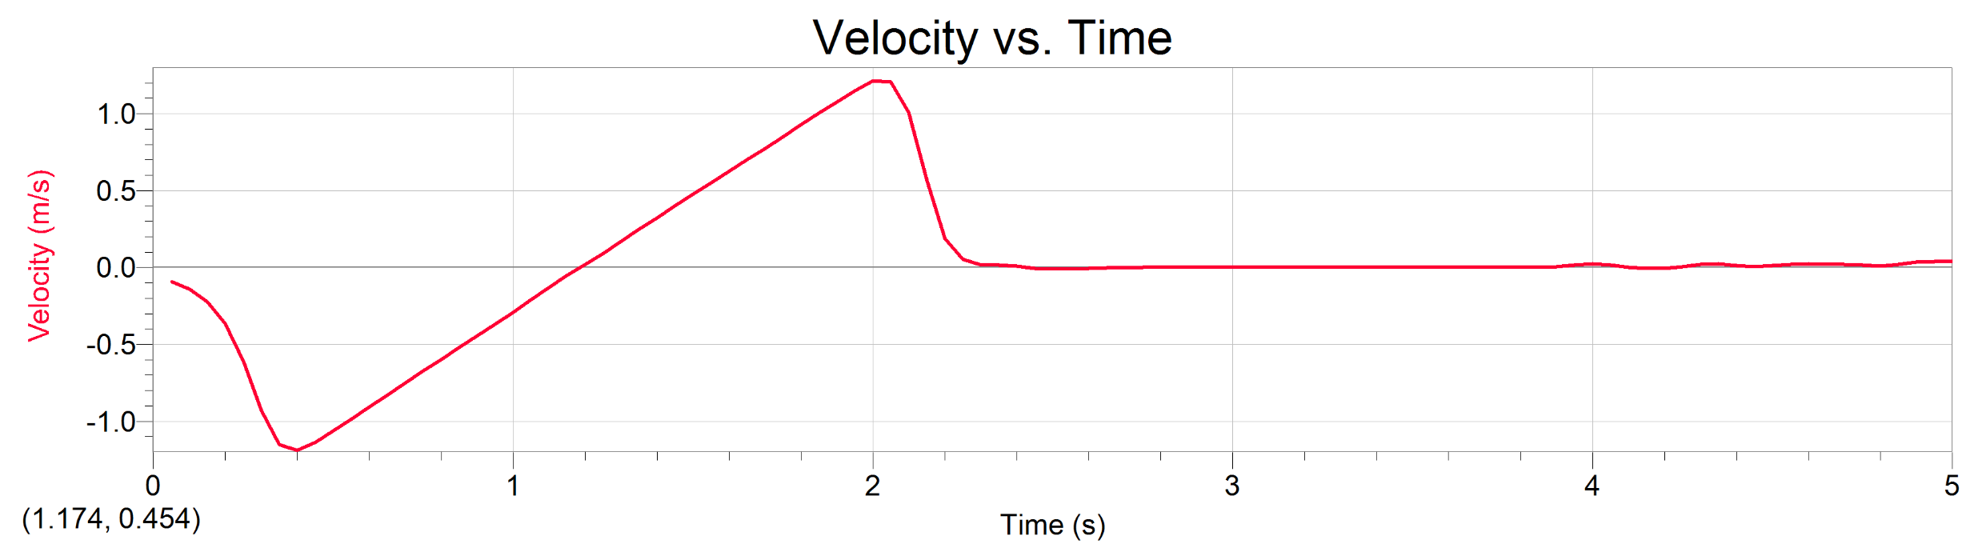The graph below is an example of some data collected through an experiment where a dynamics trolley was given a sharp push up an incline. Under gravity it slowed down until it eventually turned around and came back down the incline. The curved end sections of the graph are regions where forces are applied to push up and then stop the trolley. The straight section is free movement up/down the plane.
2. Which direction is positive? Up or down? __________________
3. At what time did it change direction? __________________
4. Describe the change in motion that occurs in the straight section between 0.6 s and 1.9 s.

|  |
| --- |
|  |
|  |
|  |

[7 Marks]

1. Calculate the gradient of that section (including units) and demonstrate with appropriate formulae what this value represents.

|  |
| --- |
|  |
|  |
|  |
|  |
|  |

[5 Marks]

1. Read the experimental method provided and complete the following.

|  |  |
| --- | --- |
| Independent variable |  |
| Dependent variable |  |
| Two Controlled Variables |  |

[2 marks]

Write an appropriate hypothesis.

|  |
| --- |
|  |

[1 mark]

1. Design and neatly draw up an appropriate results table to collect and process the required data in the space below. You may want to refer to the processing the results section below to ensure you have space for everything required.

[5 Marks]

**THIS IS THE END OF THE PRE – INVESTIGATION ASSESSMENT STAGE**

**Processing the Results**

1. Show your working for at least one of your acceleration calculations

[2 Marks]

**You may use this space for additional calculations**

1. Using the provided graph paper, graph the average acceleration vs. sin (θ) on a set of axes where the sin (θ) values range from 0 to 1.

[5 Marks]



A displacement vs time graph and velocity vs time graph from a similar experiment are shown below.

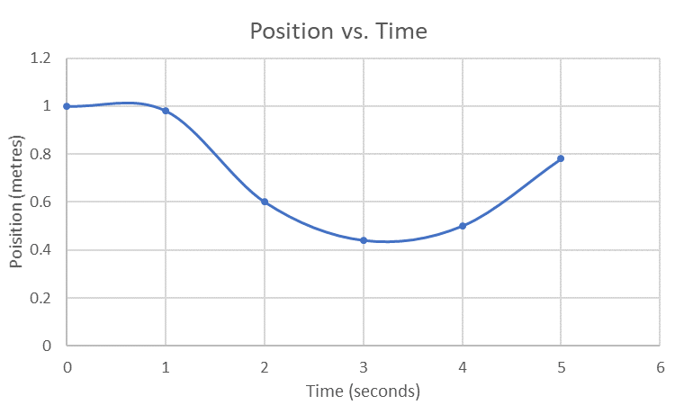

1. Explain the shape of the displacement time graph.

|  |
| --- |
|  |
|  |
|  |

[2 Marks]

1. Explain the shape of the velocity time graph.

|  |
| --- |
|  |
|  |
|  |

[2 Marks]

1. Calculate the gradient of your average acceleration vs. sin (θ) graph and use this to calculate an experimental value for “g”. You logic should be explained below.

|  |
| --- |
|  |
|  |
|  |
|  |
|  |
|  |
|  |
|  |
|  |
|  |
|  |
|  |

[5 Marks]

1. Draw a line of best fit on your graph. This can be used to provide another experimental value for “g” without the need for a gradient calculation. Explain the logic for this method.

|  |
| --- |
|  |
|  |
|  |
|  |
|  |
|  |
|  |
|  |
|  |
|  |
|  |
|  |

[2 Marks + 4 Marks]

1. Compare the two methods from questions 5 and 6 above, commenting on the validity of each.

|  |
| --- |
|  |
|  |
|  |
|  |
|  |
|  |
|  |
|  |

[3 Marks]

**Analysis, Evaluation and Conclusions.**

Finally, write an appropriate conclusion including an evaluation of issues that may have presented themselves during the experimental method and / or processing of results.

|  |
| --- |
|  |
|  |
|  |
|  |
|  |
|  |
|  |
|  |
|  |
|  |
|  |
|  |
|  |
|  |
|  |
|  |
|  |
|  |
|  |
|  |
|  |
|  |
|  |
|  |
|  |
|  |

[5 Marks]